SpendWise

Introduction
TEAM ID: SWTID-2026-9328 TEAM SIZE:5
TEAM LEADER: S.SRUTHI
GMAIL I’D:sruthisivasamy22@gmail.com
NM I`D: 7ECD93286135AB7ACB2420985766F592
TEAM MEMBER:V.MOHANAPRIYA
GMAIL I’D:mohanaveerappan31@gmail.com
NM I`D: 886C1A53A736A16AC0C473F865451F5A
TEAM MEMBER:S.PREETHI
GMAIL I’D:saravananpreethi70@gmail.com
NM I`D: 37F3700C7D7899DB55040702E867416D
TEAM MEMBER: K.RAGAVI
GMAIL I’D:ragavisabari4@gmail.com
NM I`D: D6858B9CCDFE37089A544C2EDF79044C
TEAM MEMBER:A.RAMYA
GMAIL I’D:ramyaananth2007@gmail.com
NM I’D:OD9D56816523FB5A00E413B1A5863489

Project Overview
SpendWise is a backend application designed to help beginner developers learn how to build secure REST APIs using Node.js, Express, MongoDB, and JWT authentication. The project focuses on implementing user authentication and basic CRUD operations in a clean and simple way so students can understand how backend systems work in real-world scenarios.

Key Objectives:
- Provide secure user authentication using JWT
- Enable basic CRUD operations on user data (transactions/records)
- Demonstrate MongoDB integration using Mongoose
- Show how protected routes work using middleware
- Maintain a simple and beginner-friendly backend architecture

Target Users:
- Beginner backend developers
- Students learning Node.js and Express
- Freshers preparing for technical interviews
- Anyone who wants a simple project to understand JWT and MongoDB ● Learners who want hands-on practice with REST APIs

Project Instruction
SpendWise is a backend-only project built using Node.js and Express.

Quick Start:
npm init npm install npm run dev

Steps to Create the Project:
- Choose or create a directory for the backend project.
- Open terminal and navigate to that directory. ● Initialize Node.js project using npm init.
- Install required packages: express, mongoose, jsonwebtoken, bcrypt, cors, dotenv.
- Create folders: models, routes, controllers, middleware, config. ● Start the server using npm run dev.
- Test APIs using Postman or Thunder Client at http://localhost:5000.

Pre-requisites:

Software Requirements

Software Purpose
Node.js JavaScript runtime for backend
MongoDB NoSQL database for data storage
npm Package manager
Git Version control system
Code Editor VS Code or similar

Knowledge Requirements
- JavaScript ES6+
- Node.js and Express.js
- MongoDB and Mongoose
- JWT authentication
- Basic REST API concepts
- Git basics

Thumbnail for Project
- A simple backend project thumbnail representing:
Node.js + Express + MongoDB + JWT + CRUD APIs

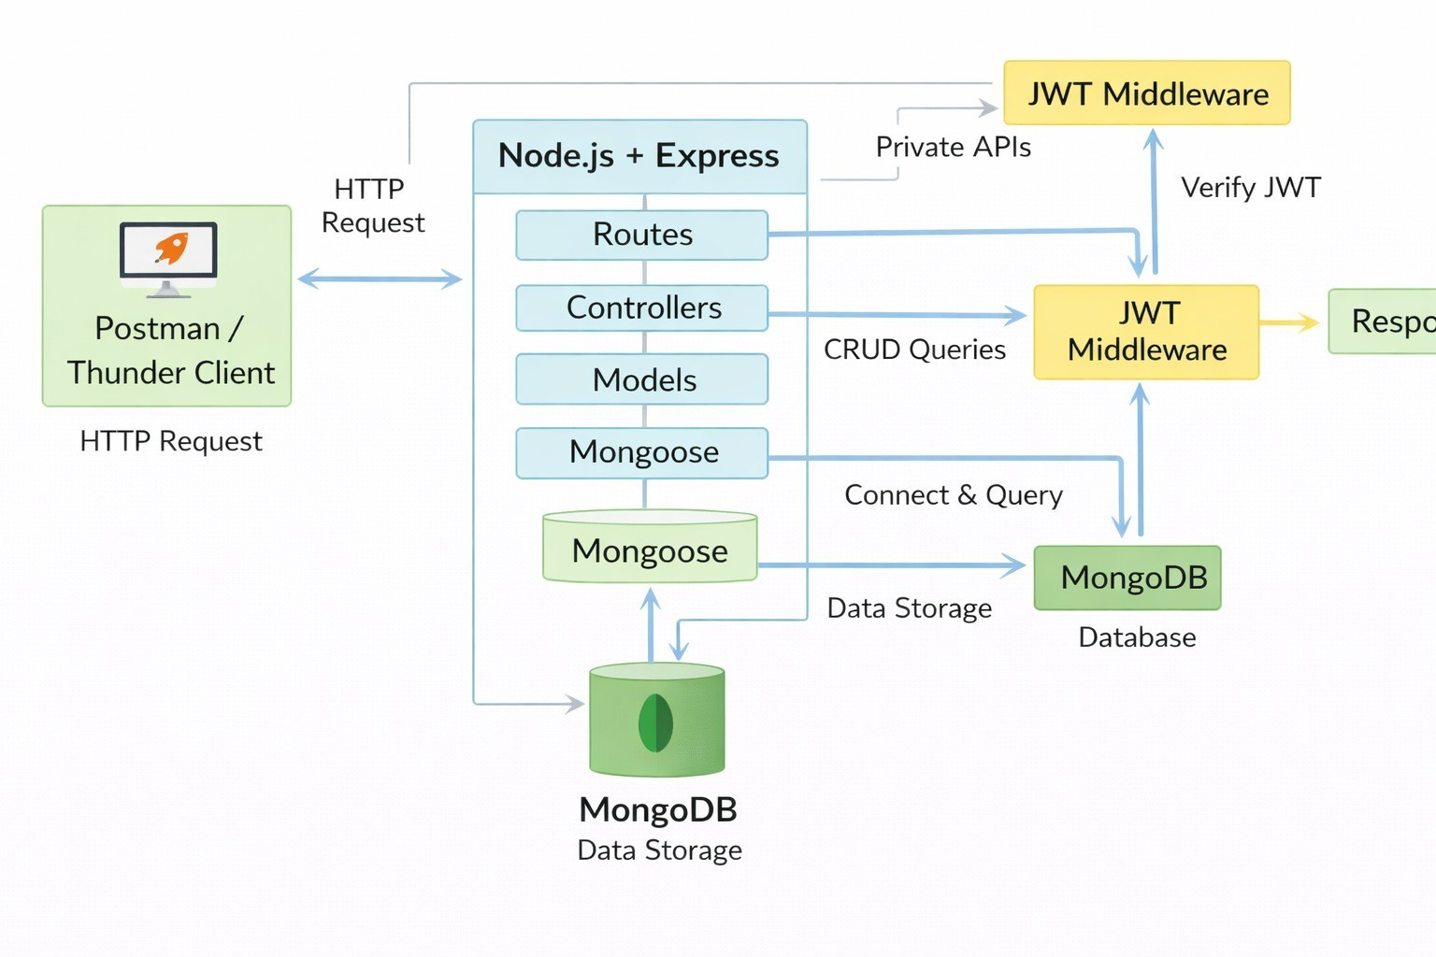
Project Architecture Image

Technical Architecture

Backend Architecture (Node.js + Express)
  - Controllers: Handle business logic for authentication and CRUD
  - Models: Mongoose schemas for User and Transaction
  - Routes: API endpoints for auth and CRUD operations
  - Middleware: JWT verification and request protection
  - Configuration: Database connection and environment variables

Database Architecture (MongoDB)
  - Users Collection:
_id, name, email, password (hashed), createdAt
  - Transactions Collection:
_id, userId (FK), title/description, amount/value, createdAt
  - Relationship:
Many Transactions belong to One User

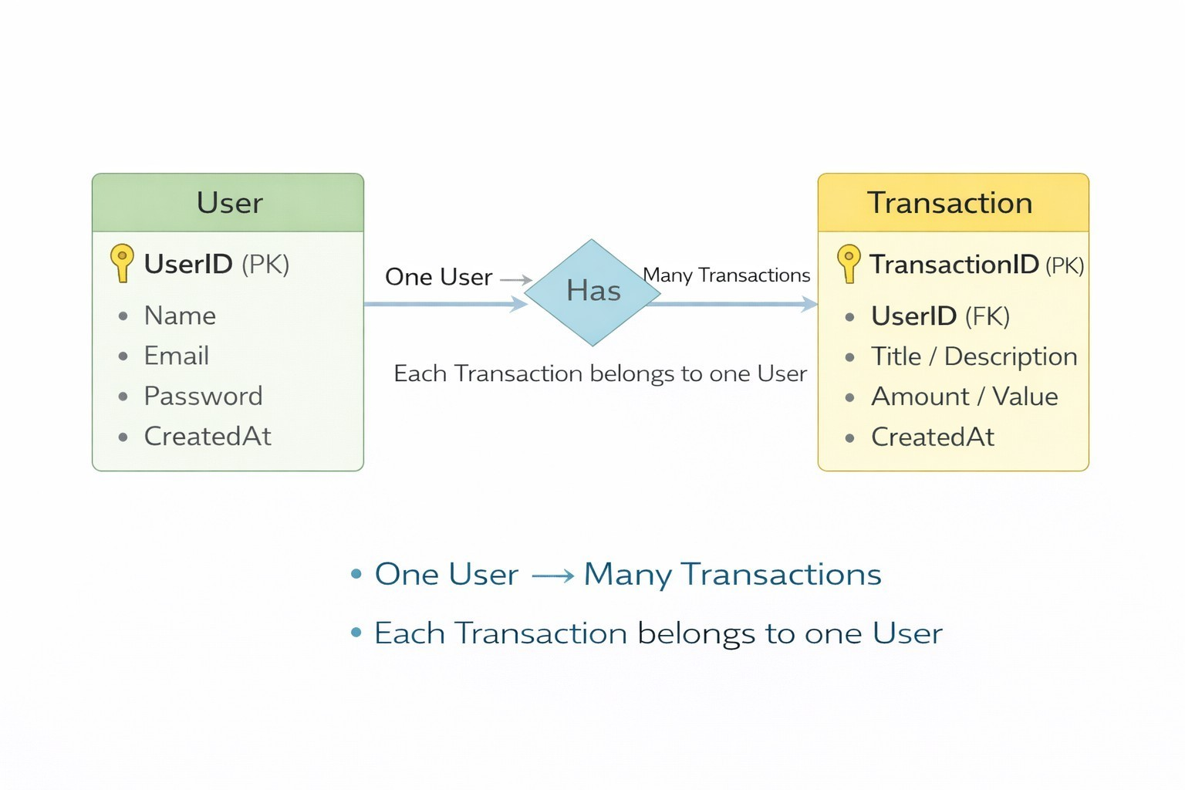
ER Diagram

Features

Feature Description
User Authentication JWT-based registration and login
CRUD Operations Create, Read, Update, Delete transactions Protected Routes Secure APIs using JWT middleware MongoDB Integration Store and fetch data using Mongoose

Roles and Responsibilities

Student / Developer:
- Write backend code
- Create APIs
- Test APIs using Postman/Thunder Client
- Push code to GitHub

System (Backend):
- Authenticate users using JWT
- Handle CRUD operations
- Store and fetch data from MongoDB
- Protect private routes

Users Flow:
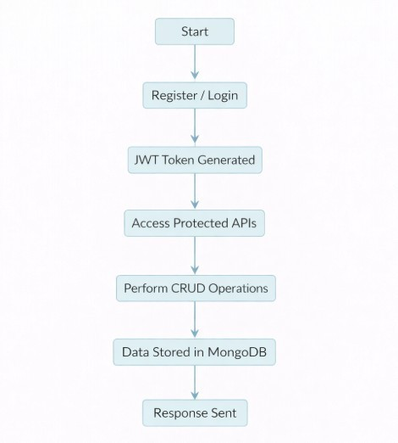

PROJECT SETUP AND CONFIGURATION
Folder Structure
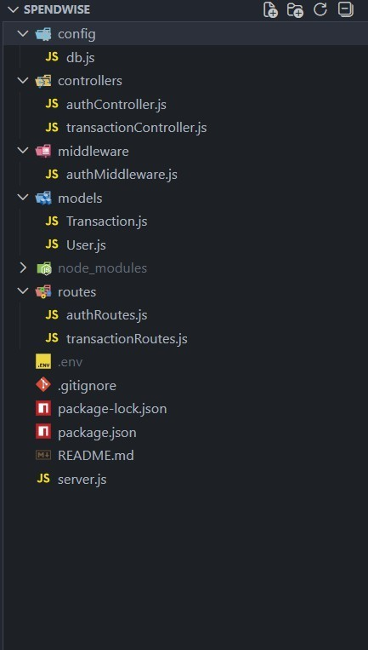

Project Setup
- Install required tools:

  - Node.js
  - MongoDB
- Create project folders:
  - server folders (models, routes, controllers, middleware, config)

- Install Backend Packages:
  - Express
  - Mongoose
  - Cors
  - Jsonwebtoken
  - Bcrypt
  - Dotenv

BACKEND DEVELOPMENT
  - Setup Express server
  - Create server.js file
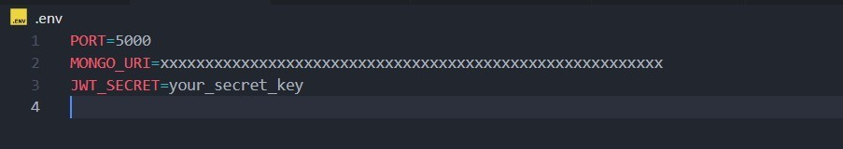
  - Create .env file and define PORT and DB URL
  - Configure middleware (cors, express.json) ● User Authentication:
0 Create Register and Login routes
    - Generate JWT token
    - Protect routes using middleware

  - Define API Routes:
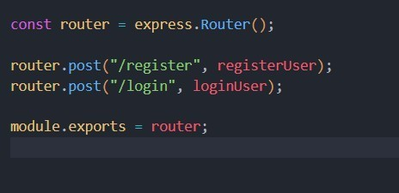
0 Auth routes
    - Transaction CRUD routes

  - Implement Data Models:

0 User schema
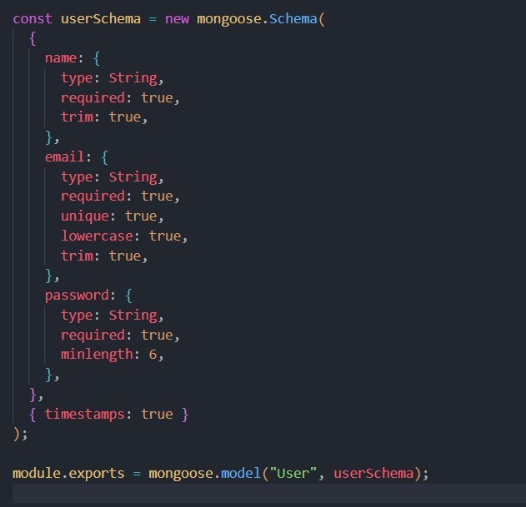

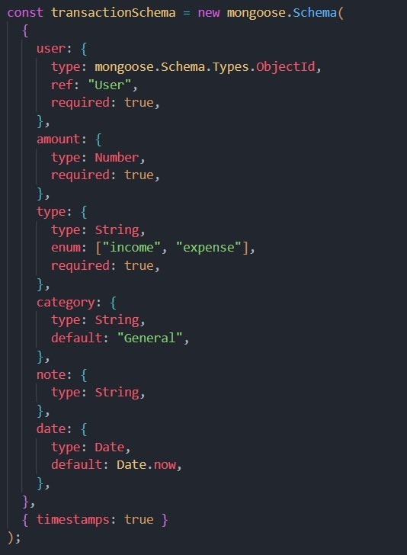
    - Transaction schema
  - Implement CRUD operations
  - Add basic error handling

DATABASE DEVELOPMENT

Configure MongoDB
  - Use MongoDB Atlas or local MongoDB
  - Store connection URL in .env file
  - Connect using Mongoose

Create Database Connection
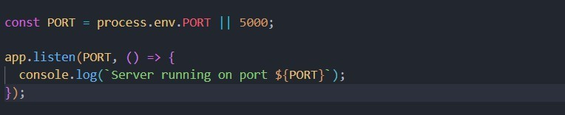
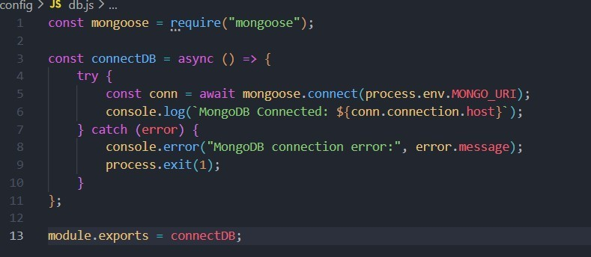
  - Create a config file for DB connection

  - Use mongoose.connect()
  - Handle success and error cases

Create Schema and Models

User Model:
  - Name
  - email
  - password

Data / Transaction Model:
  - userId
  - title / description
  - amount / value
  - timestamps

PROJECT EXECUTION
Project Execution Steps:
- Start MongoDB
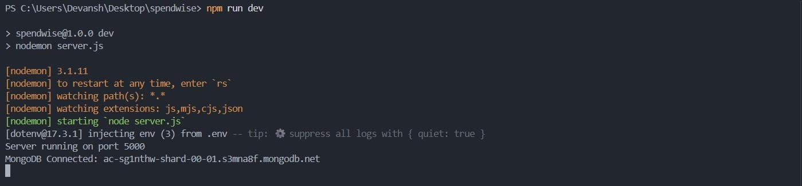
- Run backend server
- Test Register API
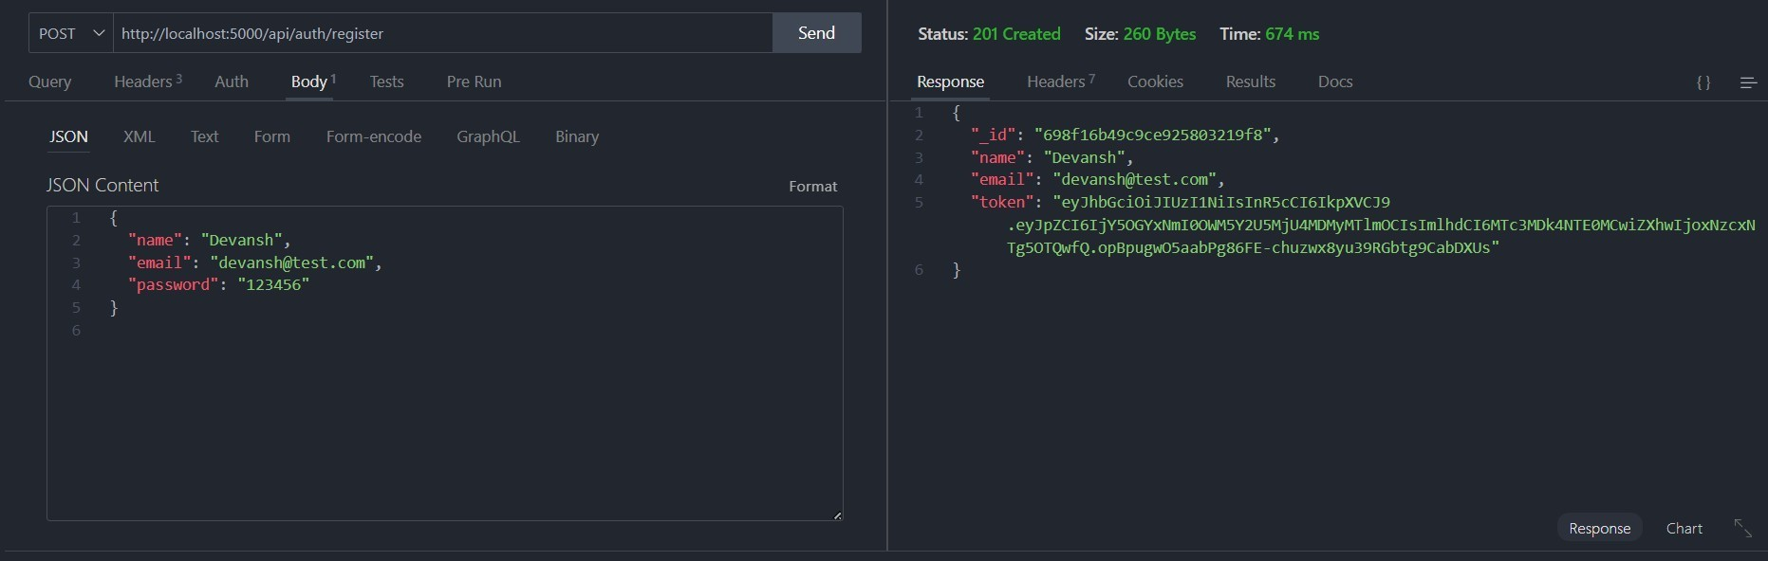

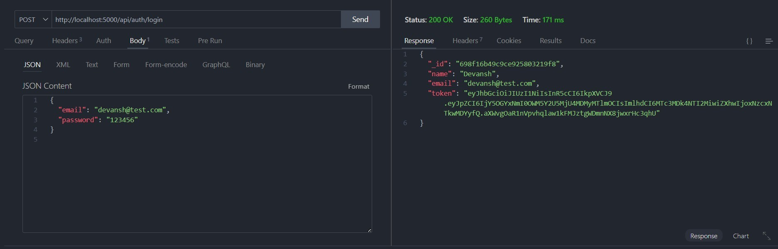
- Test Login API

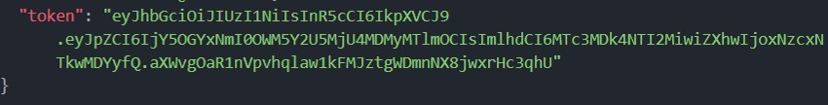
- Copy JWT token
- Use token to access protected CRUD APIs
- Perform Create, Read, Update, Delete operations

OUTPUT SCREENSHOT
- Register API

- Login API

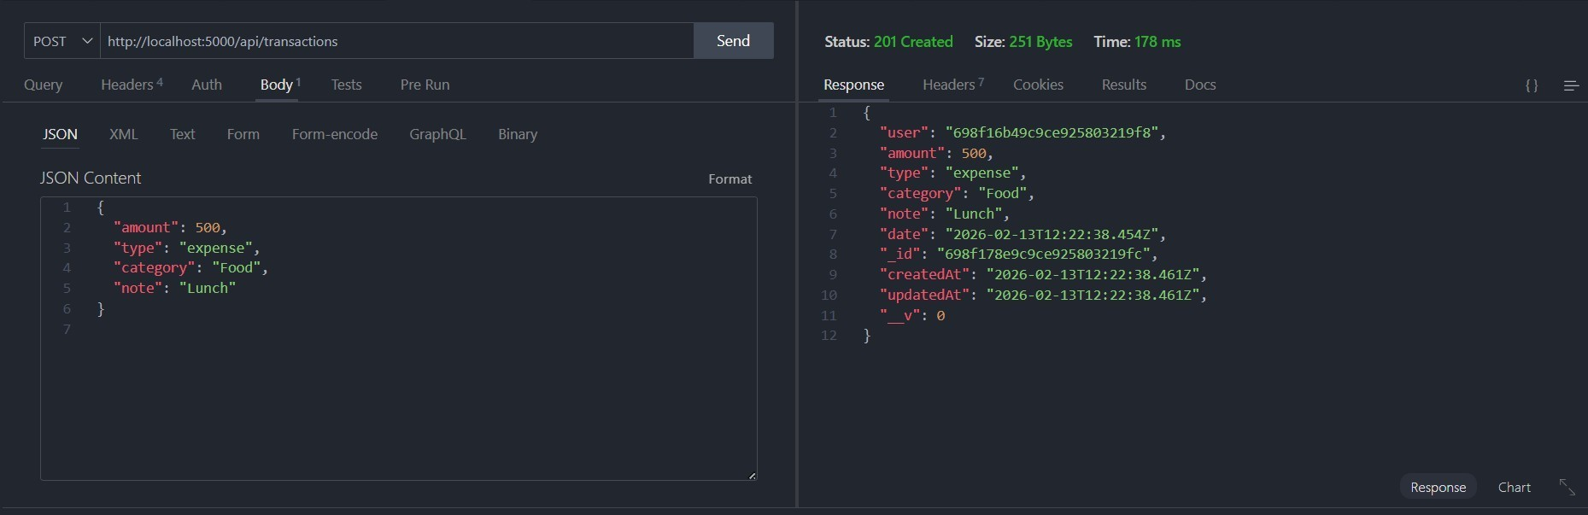
- Create Transaction

- Get information
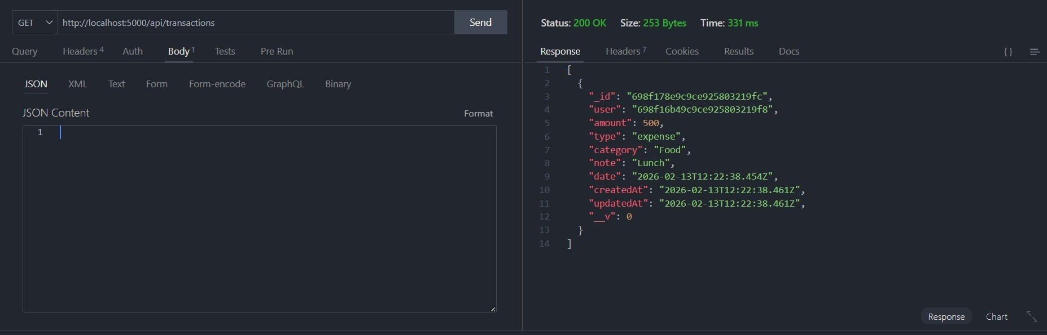

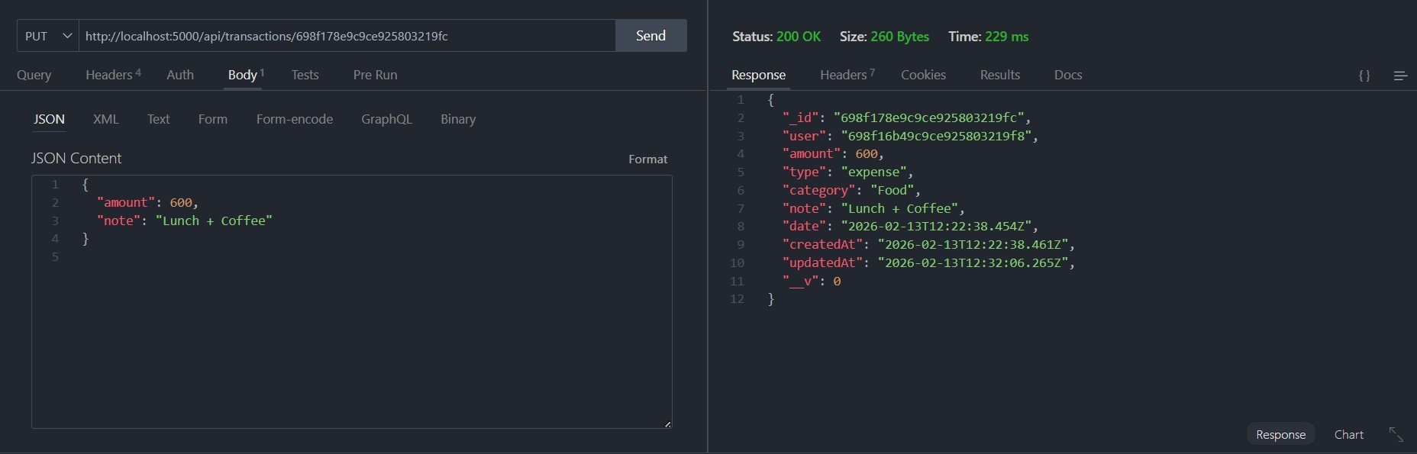
- Update API

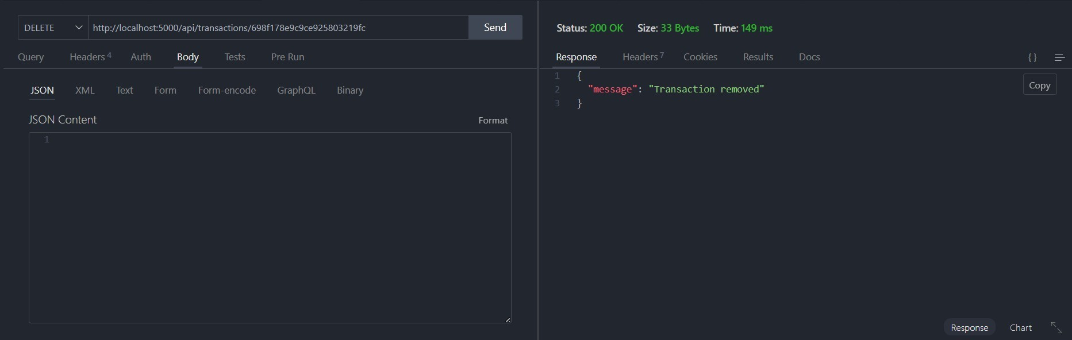
- Delete API

Project Demo Video
SpendWise (video).mp4

https://github.com/maheswaris731-gif/Spendwise.gitDrive Link : SpendWise

